
NAME : STEPHEN KIMANI

ADMMISSION: BSCCS/2024/57444

SCHOOL OF COMPUTING AND INFORMATICS

DEPARTMENT OF INFORMATION TECHNOLOGY

UNIT CODE: BIT 3208

UNIT TITLE : ADVANCED WEB DESIGN

PROJECT TITLE : CAMPUS EVENT BOARD : A CAMPUS EVENT
MANAGEMENT SYSTEM

Lecturer: Michael Nyoro

JUNE 2026

Contents
WEEK 1 3
Set up a local development environment 3
WEEK 2 5
Wireframe design 5
Week 3: JavaScript and PHP Basics 7
Creating an event product catalog using HTML, CSS, and JavaScript. 7
Implementing form validation 8
5. Password Strength Checker 8
Week 4 9
Week 5 Lesson – Advanced Web Design and Development 10
CREATING TABLES 10
CRUD Operations 10
Connecting to a database 11

WEEK 1

Set up a local development environment
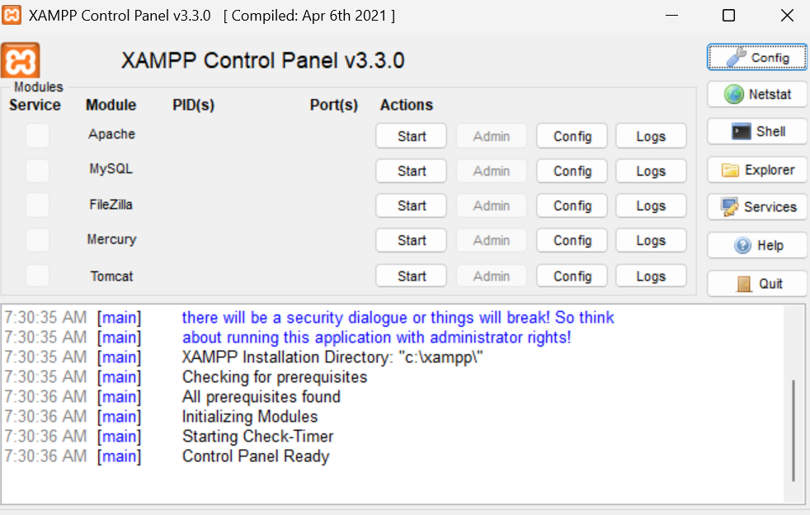
Figure 1: installation of XAMPP

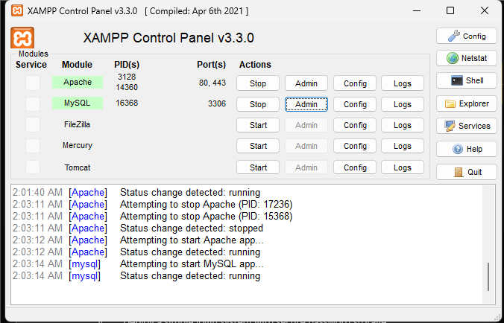
Figure 2: Apache and MYSQLI running
- Through this project, I learned how to build a full-stack web application by connecting a JavaScript frontend to a PHP backend and a MySQL database using XAMPP as the local development environment. I learned how PHP handles API requests, how mysql executes SQL queries, and how data flows between the browser and the database in real time. Technologies used include HTML, CSS, JavaScript, PHP, and MySQL. The main challenge I encountered was understanding why PHP projects must run through localhost instead of Live Server, and correctly placing all files inside the htdocs folder so Apache could serve them properly.

WEEK 2

Wireframe design
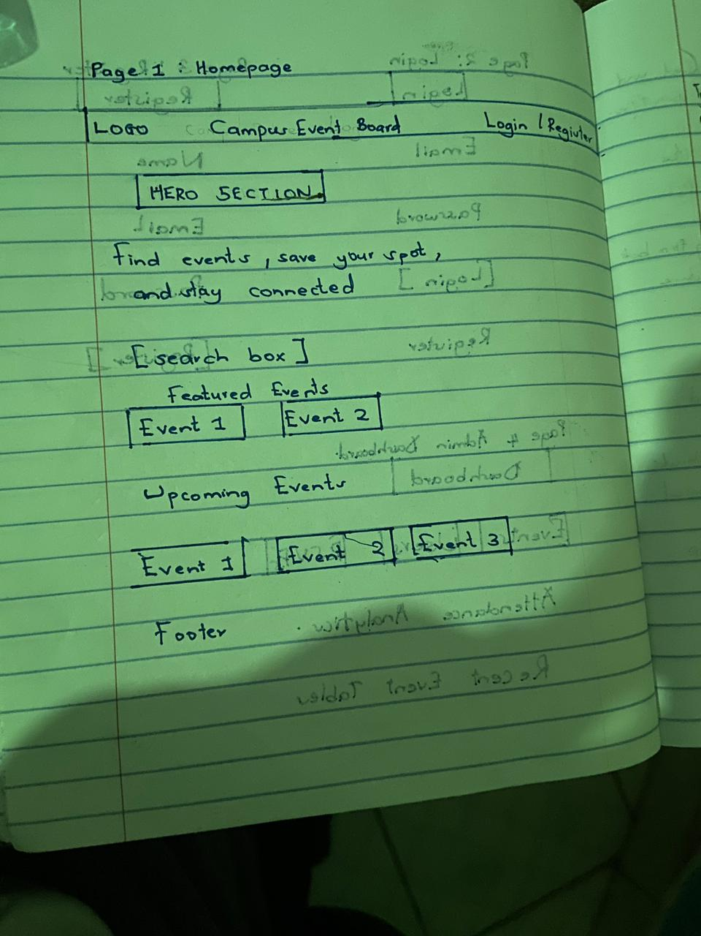
Figure 2: Homepage
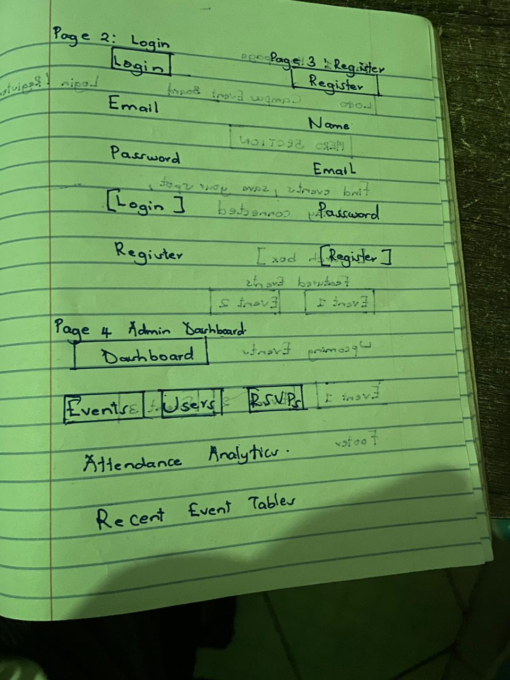
Figure 3: login page & Admin dashboard

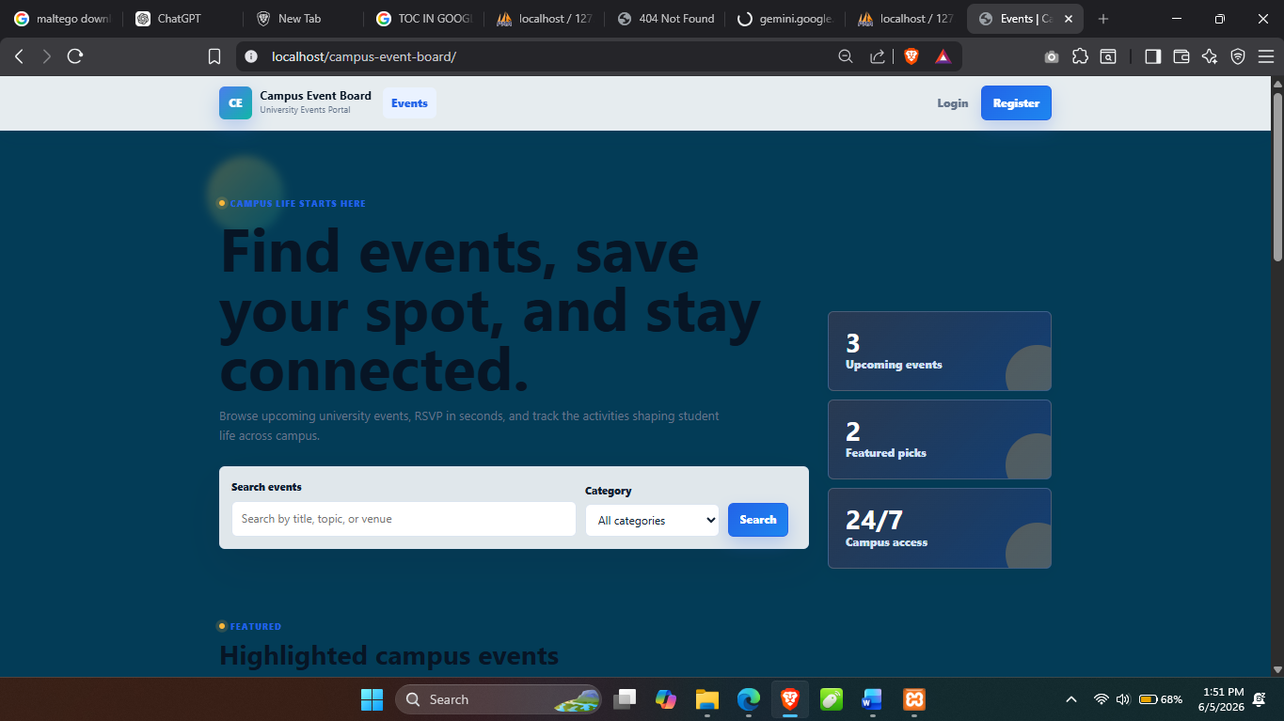
Figure 4: shows the Graphics User Interface of the campus event management system .

Week 3: JavaScript and PHP Basics

Creating an event product catalog using HTML, CSS, and JavaScript.
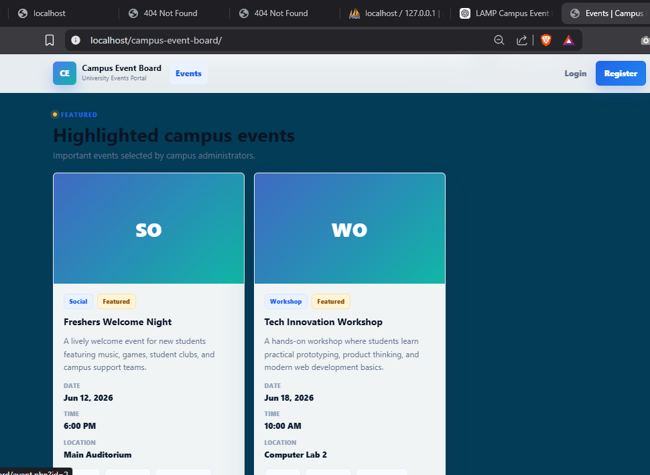
Figure 5:Event catalog

Implementing form validation
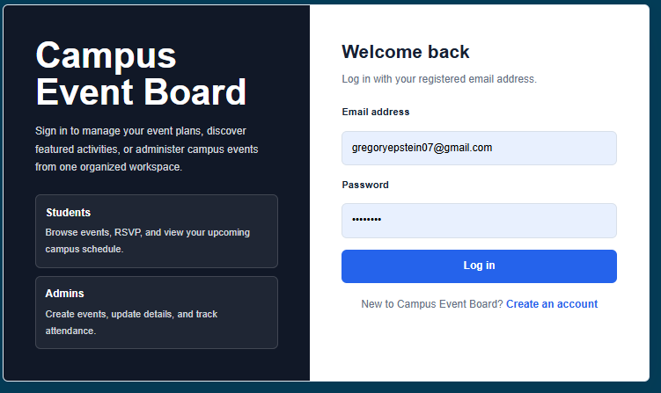
Figure 6: login page

5. Password Strength Checker
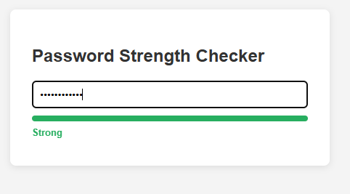
Figure 7 :Password Strength Checker

Week 4
Figure8 :Folder Organization
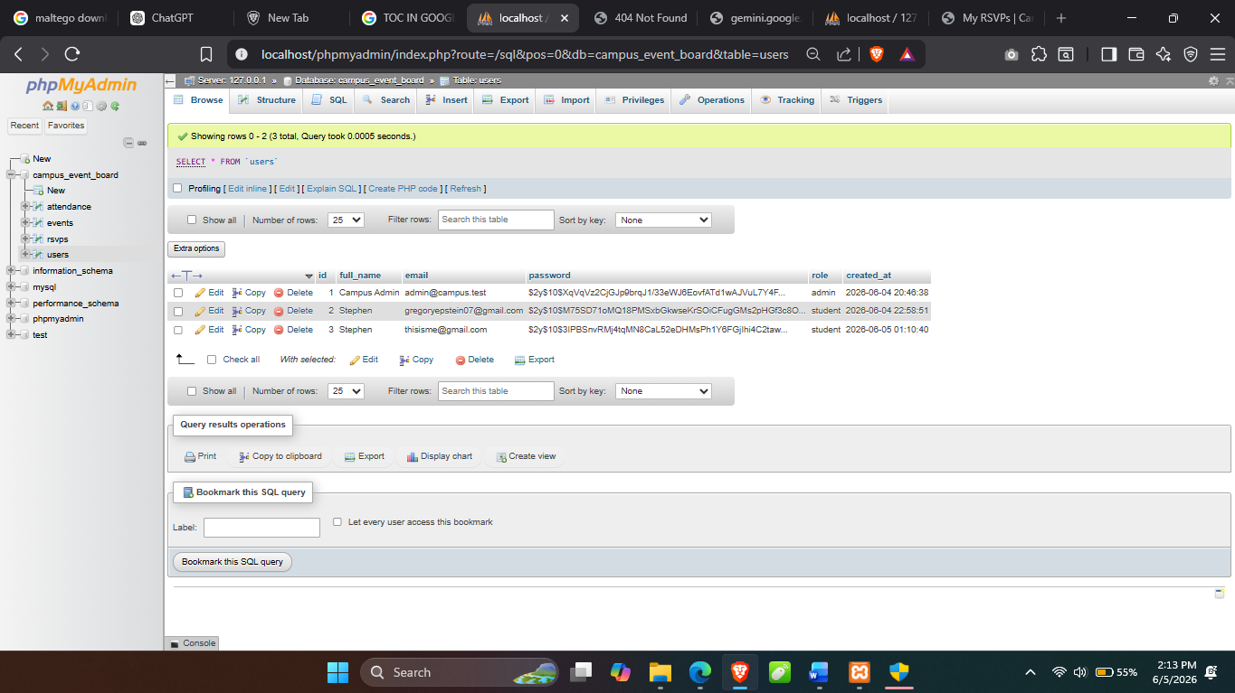
Figure 9:shows PHP syntax practice including variables, foreach loops and functions, confirmig that PHP can dynamically generate HTML output

Week 5 Lesson – Advanced Web Design and Development

CREATING TABLES
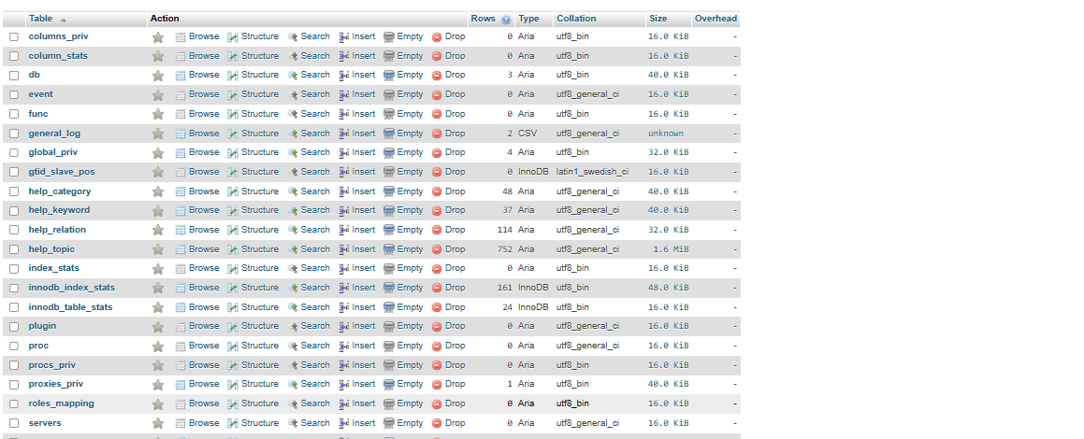
Figure 10: creating tables

CRUD Operations

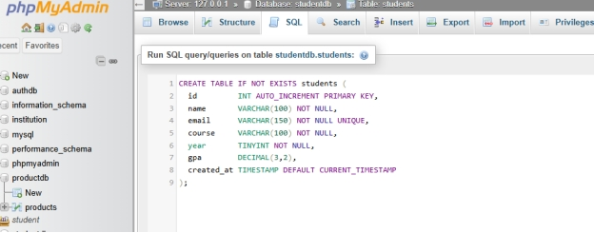

Connecting to a database
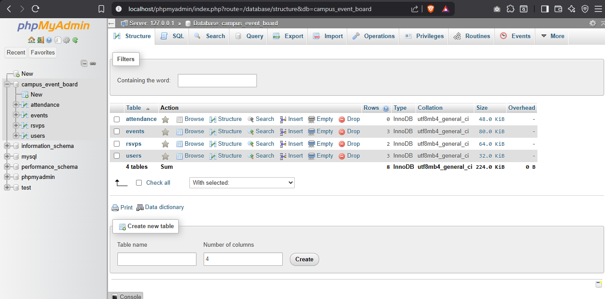
Figure 9 shows successful connection between PHP and MySQL using mysqli_connect() with localhost, root user, and campus event board database. This confirmed that Apache and MySQL services were properly configured in XAMPP.

